## **Advance Tasks**

Task: 1

Get Scrub ID and Navigate to Rating Scale.

Description:

Step 1 🡪get the scrub id from url and print on console

step 2---> make the url for rating scale designer and navigate to rating scale page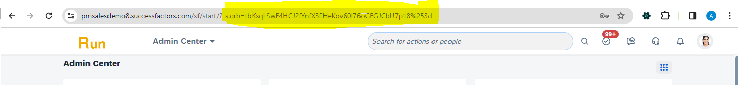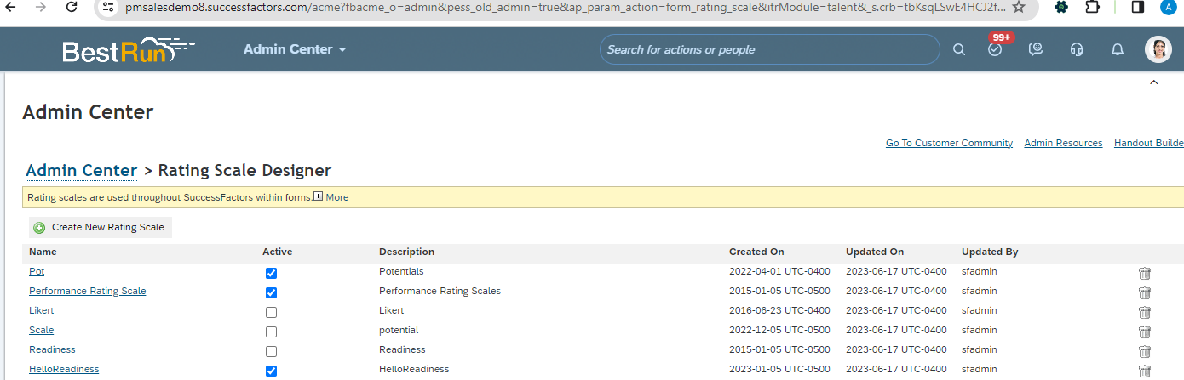

## Task: 2

Scrape Rating Scale

Description: Step 1 🡪 scrape rating scale and print on console.

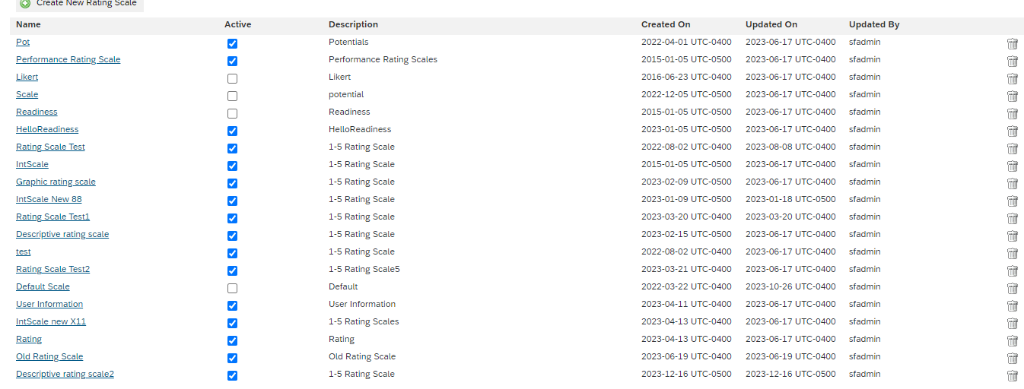

Step 2 🡪click on rating scale name and scrape them one by one

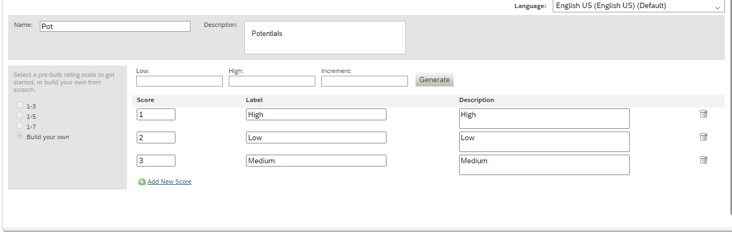

## Sample : <https://docs.google.com/spreadsheets/d/1OGTKqeWjOKY3QhtxO6C6lZJmRGqna1ptZw6ariyr5dY/edit#gid=0>

And Update Instance Record into Google Sheet.

## Task: 3

Validation of Rating Scale.

## Task: 4

Automation of Rating Scale.

Task: 5 Succession Settings Gsheet (Model & Controller).

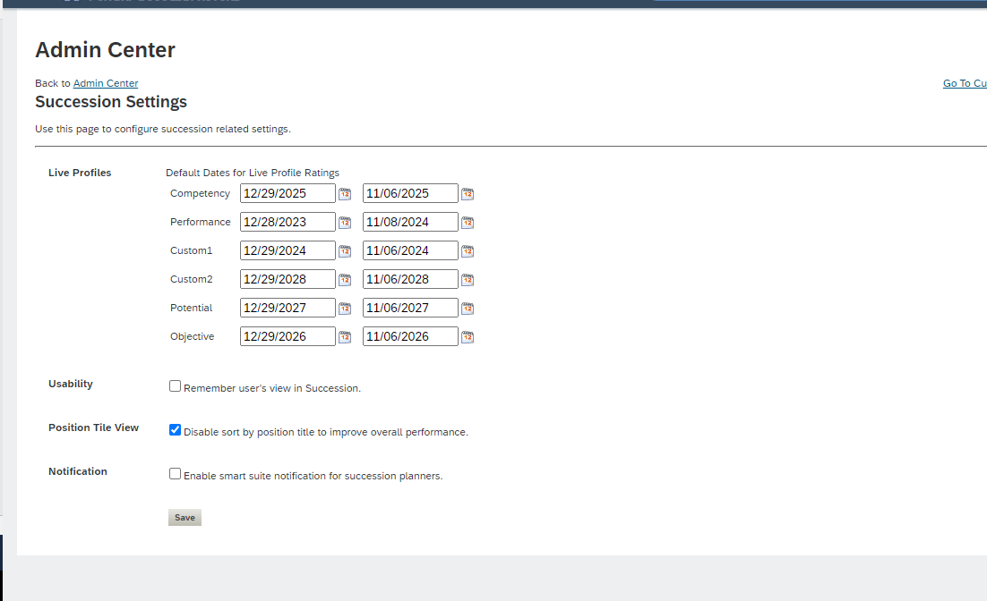

## Task: 6

Scrape Succession Settings Screen.

## Task: 7

Automation Succession Settings Screen.

## Task: 8

Validation Succession Settings Screen.

Task: 9 EMP PROF Standard Elements Gsheet (Model & Controller).

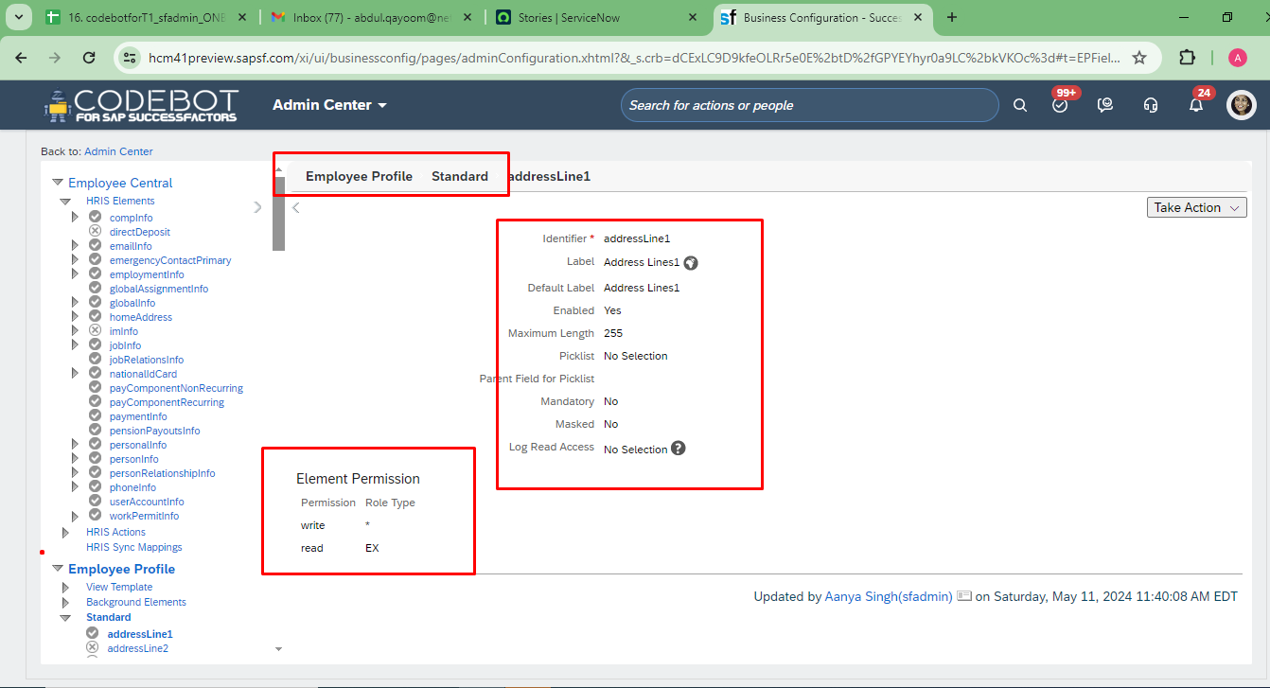

Task: 10

Scrape EMP PROF Standard Elements Screen.

## Task: 11

Automation EMP PROF Standard Elements Screen.

## Task: 12

Validation EMP PROF Standard Elements Screen.